Prototype testing feedback analysis

Contents

1: Gameplay & concept feedback 2

Translating feedback into tasks 3

Mechanics feedback 4

Translation to tasks 5

Controls feedback 7

Style feedback 8

List of peeps to contact for next playtest 9

Bonus positive feedback 9

# Gameplay & concept feedback

**Positive Feedback**

* Movement controls praised
* Core concept is solid, distinct from other survival games
* Game runs smoothly without issues
* Enjoyable gameplay with potential for cool combos
* Positive sentiment about the league style ADC gameplay in vampire survivor style games
* Combos and wave farming aspects appreciated
* Excitement about the concept of ability-based roguelike gameplay

**Negative Feedback**

* Gameplay stagnates after a few minutes, lacking new upgrades and increased difficulty
* Suggestions for progression: more ability upgrades, different enemy types, varied areas, mini bosses, main bosses, faster and tankier enemies, different game modes
* Quality of life issues: getting chump blocked, aiming challenges for some abilities, attacking and walking with the same button feels awkward
* Desire for unique ideas due to saturated genre (red ocean)
* Lack of visual feedback on abilities
* Dodge key feedback needed
* Some abilities felt useless, while AoE abilities were appreciated
* A-click functionality suggested to improve gameplay

Concept praised by target audience. Lower ratings came from lack of content, higher ratings came from appreciation for original spin on the roguelike survivors genre. Doubts came from the fact that the market is very saturated so it might be hard to get into no matter how good your game is.

## Translating feedback into tasks

**Design**

1. **Progression Enhancement:**
   * Introduce more ability upgrades, diverse enemy types, varied areas, mini bosses, main bosses, faster and tankier enemies, and different game modes to combat stagnation.

**Controls:**

1. **Movement and Attacking Controls Optimization:**
   * Ensure movement feels as responsive as possible.
   * Attack move button.
   * Clicking on enemies more forgiving.

**Quality of Life/Feedback:**

1. **Visual Feedback Improvement:**
   * Implement visual cues for abilities to enhance player understanding and immersion.
   * Address lack of visual feedback on certain abilities to make their impact more apparent to players.
2. **Dodge Key:**
   * Rework mobility skills to dodge key.
3. **Abilities Balance:**
   * Rebalance abilities to ensure all of them are impactful and useful, considering player feedback on some abilities feeling useless.
4. **Aiming Challenges Resolution:**
   * Address aiming challenges for specific abilities to make them more user-friendly, ensuring players can use them effectively without frustration.
5. **Chump Blocking Issue Fix:**
   * Resolve the issue of getting chump blocked to improve player movement and prevent frustrating gameplay experiences.

# Mechanics feedback

**Positive Feedback (Higher Frequency):**

* Movement speed buffs enhance player control and fun factor
* Positive impact of movement control on gameplay experience

**Negative Feedback (Higher Frequency):**

* Certain abilities lack impact and value, specifically mentioning E smokescreen and R bullet frenzy abilities
* Dash ability perceived as useless due to limited functionality
* Disintegrate ability needs tweaking for better balance
* Kiting mechanics feel awkward, possibly due to issues with recognizing attacks after movement, leading to janky gameplay experience
* Dash ability's perceived lack of utility due to the importance of AoE skills
* Clunky movement and kiting mechanics make survival unintentionally harder and less enjoyable

**Negative Feedback (Medium Frequency):**

* Movement speed buffs, while fun, might disrupt the balance in a game where kiting is crucial
* Dash ability considered useless due to absence of pass frames

## Translation to tasks

**Balance:**

1. **Ability Impact and Value Assessment:**
   * R bullet frenzy abilities to identify weaknesses and enhance their impact and value in gameplay.
2. **Disintegrate Ability Tweaking:**
   * Fine-tune the Disintegrate ability for better balance, considering player feedback on its effectiveness and cooldown (its OP).
3. **Movement Speed Buffs Balance Check:**
   * Evaluate the impact of movement speed buffs on gameplay balance, ensuring they enhance player control without disrupting the game's overall balance, especially in kiting scenarios.
4. **Dash and Smokescreen Ability Enhancement:**
   * The dash and smokescreen ability will be reworked into a dodge button.

**Design:**

1. **Kiting Mechanics Refinement:**
   * Refine kiting mechanics to address the awkwardness experienced by players, possibly caused by issues with recognizing attacks after movement. Aim for smoother, more intuitive gameplay experiences during kiting. -> Some attack commands get eaten by movement commands

**Movement Animation:**

1. **Clunky Movement and Kiting Mechanics Improvement:**
   * Improve overall movement and kiting mechanics to eliminate clunkiness and make survival more enjoyable. Enhance responsiveness and fluidity in character movement to enhance player experience.

* The most fun mechanic was damaging a lot of enemies at once.
* Dodging enemies and surviving was too easy for most people.
* Abilities need more balancing to become more fun
* Choosing abilities need more options and synergies to become more fun
* Attacking/kiting enemies needs more optimization (responsiveness, attack move) to become more fun. But it’s already good.

Game was considered easy. Mostly due to lack of enemy variation and the fact you can always just run away from them.

# Controls feedback

**Positive Aspects:**

* Controls feel responsive, providing a good foundation for gameplay.
* Using QWER buttons for actions makes sense and is intuitive.
* Appreciation for the game not hand-holding players, allowing for precision and accuracy in mouse clicks.
* Generally, the controls are easy to understand and work well for players familiar with games like League of Legends and Baldur's Gate.

**Areas for Improvement:**

* Some controls and interactions feel finicky, especially with enemies sticking to the player and targeting issues.
* Suggestions for the option to switch between move and shoot, indicating a desire for more control flexibility.
* A desire for additional movement and control options to enhance gameplay experience.
* Feedback about the need for clearer indicators and guidance for ability usage, especially when they don't appear as expected.
* A request for a quick tutorial or guide on movement controls for new players to ease the learning curve.

**Neutral Feedback:**

* Mixed opinions about the use of the same mouse click for both movement and attacking, with some players finding it weird while others not considering it a significant issue.

**Conclusion**

Adding control options will be big 😊

# Style feedback

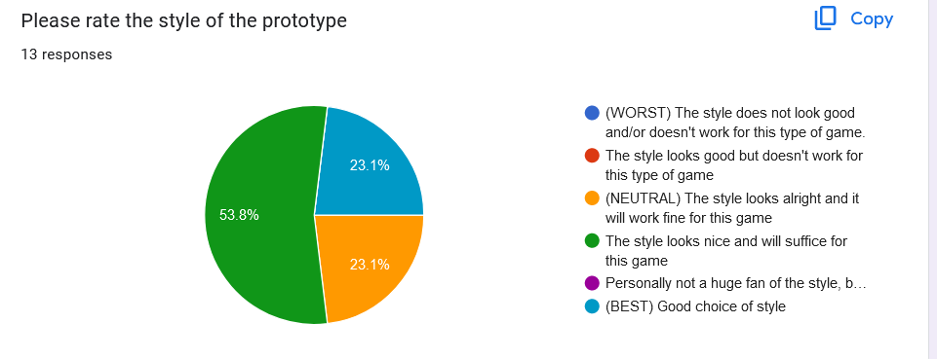

All good, no further comments.

Magic/guns fantasy or cyberpunk were the most popular options.

# List of peeps to contact for next playtest

* Fin ;v
* Jeff
* uncleben (Discord username).
* _elio_
* noahwithab
* scytheraid
* mythicalsora
* Syron, Fronter knows :)
* @Fumotokari / Yonah
* ShadowXN
* JeffJefferson
* Kenaoui
* Alan

## Bonus positive feedback

* Cool concept, I can tell you've thought a lot about the design, and knowing that you are passionate about the genre of games makes it more fun to design and discuss
* I think I gave the feedback that I have already.
* so far its a lot of fun!
* I can see a lot of potential for this game/concept
* Good path keep it up :)
* You're cool, stay positive <3
* GL <3 game's great so far